Restaurant Solutions Instructions

Group 2

Pabi Dhaliwal, Eric Nunn, Celeste Broderick​ & Fang (jenny) yuan

2018

Table of Contents

Database Setup 2

Application Execution 3

GUI Execution 3

Console Execution 5

Query Parameter Requirements 6

# Database Setup

* To install the Restaurant Solutions database open up MySQLWorkbench, and connect to your local connection.
* Before installing the data dump you must create a new user with the name ‘mm_sttest2b’ make sure this user has all privileges otherwise you will not be able to run procedures.
* To ensure all stored procedures can be run, please create a user named “mm_sttest2b” that has full database privileges. For help creating a user, please see the MySQL Workbench guide: <https://dev.mysql.com/doc/workbench/en/wb-mysql-connections-navigator-management-users-and-privileges.html>
* Next step is to go to File -> Run SQL Script and open ‘MILESTONE3DUMP.sql’ from the milestone3 folder. Once opened simply press run and it will crate an database called mm_sstest2b under your Schemas window in MySQL Workbench (don’t forget to refresh).
* If you see it mm_sstest2b under schemas then you have installed the database correctly!

# Application Execution

Using the Restaurant Solutions database program, the user has the option to use our application through two mediums. The first being the GUI which has a visual representation of all the functions our application has to offer. The second option is to run our application through a console, which excludes all the flair offered in the GUI. Both mediums perform the exact same operations.

## GUI Execution

For GUI execution simply double-click the ‘Restaurant_Solutions.jar’ file included in the Milestone 3 folder. If on a Windows computer open “Command Line”, then change your file path to be at the same location as the saved Restaurant_Solutions.jar. Then run the following code in Command Line:

*java -jar Restaurant_Solutions.jar*

The following screenshot is what you should see once the GUI opens.

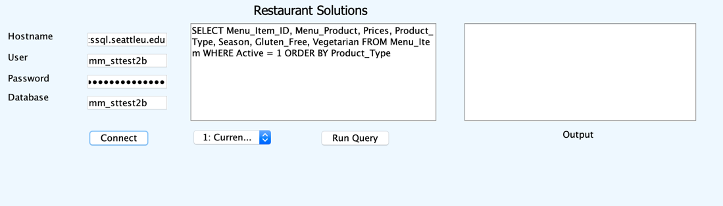

You have two options to login.

* You may use the default login using the Seattle University network but note this will connect you directly to mm_sttest2b database on the shared server, not the one you created in the setting up database portion of the instructions.
* Second method of logging in would be to replace the hostname, user, and password to the database you installed the dump in. Following the instructions on Database Setup you should have installed the database on your local connection, in which case the hostname and password can be found by clicking the information tab under the local connections and then going to edit connections. If you followed the instructions correctly the username and database name will be the following.
  + User name: mm_sttest2b
  + Database: mm_sttest2b

If your login was successful, the ‘Connect’ button should have changed to ‘Disconnect’

From here you can select any query from the drop-down menu and hit the ‘Run Query’ button to return the results.

After running a query, you will be able to export the query results by pressing the Export to CSV button. The Output display on the GUI will indicate the name of the file, which will be saved in the same folder as the application.

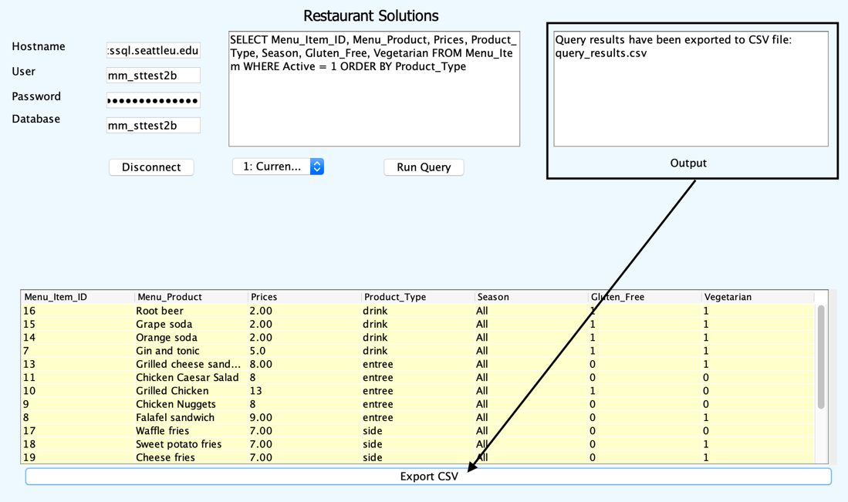

For running queries with parameters please see query parameters section at the end of the document which explains correct types and format for queries.

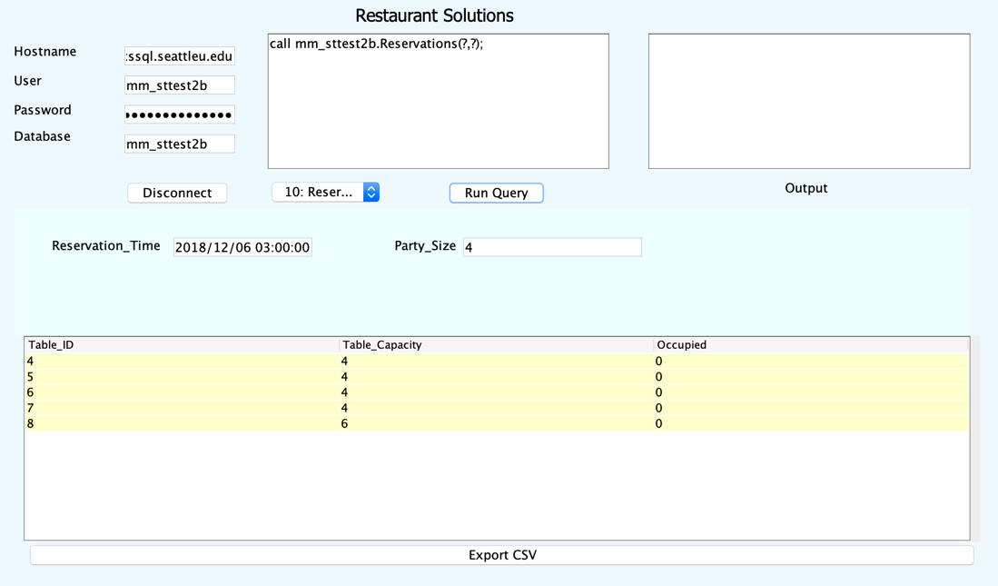

## Console Execution

Please open “Terminal” if you are using a Mac, or “Command Line” if you are using Windows. Then change your file path to be at the same location as the saved “Restaurant_Solutions.jar”. Then run the following code:

*java -jar Restaurant_Solutions.jar -console*

The below screenshot is what you should be seeing when the above code is executed correctly.

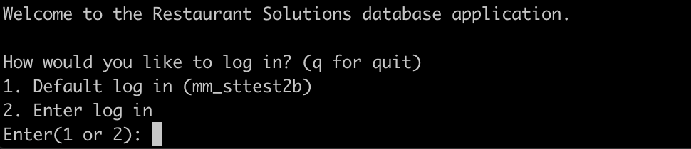

There are two ways to log in:

* First way is the Default log in using Seattle University network, Database on cssql.seattleu.edu host. All the information is pre-entered to connect to the Seattle University network, which means you have to be using the Seattle University Secure wifi, or be in Cisco AnyConnect VPN.
* Second way is for you to enter in your own database. This option will require the following information. If you completed the Database Setup correctly, you will have a user name listed below:
  + Host Name: (your own local host name)
  + User Name: mm_sttest2b
  + Password: (your own password)
  + Database Name: mm_sttest2b

Then once you have logged in, the following will appear:



This lists out the Executable queries, feel free to select any query. For parameter queries input requirements are in the “Query Parameter Requirements” section.

All queries have the option to export and input file names, this will be then generate a CSV file in the same file path location as the “Restaurant_Solutions.jar”.

## Query Parameter Requirements

For the queries that contain parameters, after the drop down with the query is clicked, input boxes for the parameters will appear. Simply fill out the input and click Run Query to run the query with your provided parameters.

* Query2: Add a new order
  + Employee (int): 2
    - Note this number should be the Employee ID.
  + TableID (int): 5
  + Notes: Allergic to Peanuts
    - Add any notes related to the order. This input is optional.
  + Menu_Item_Id (int): 5
  + Quantity (int): 2

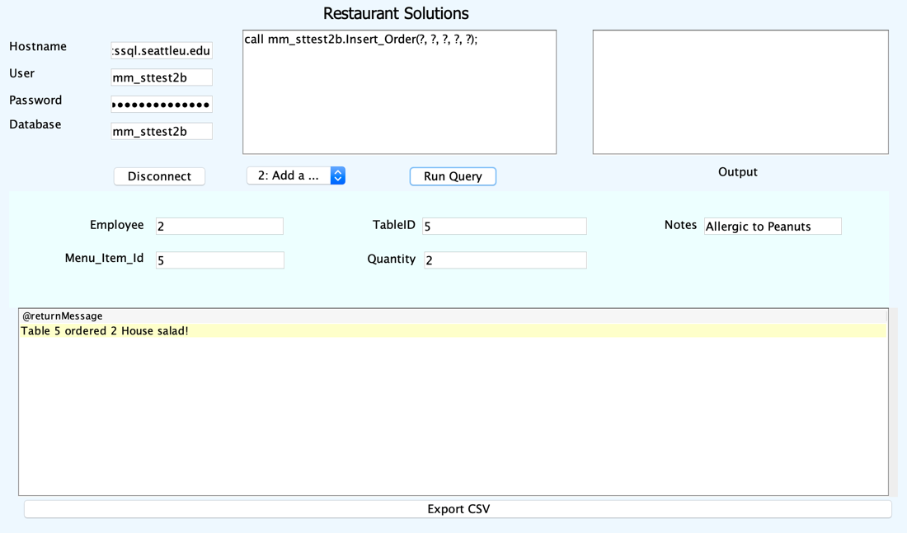

* Query3: Generate receipt for table
  + Enter in the Table ID number, and the query will retrieve the active orders associated with that table and generate a receipt.

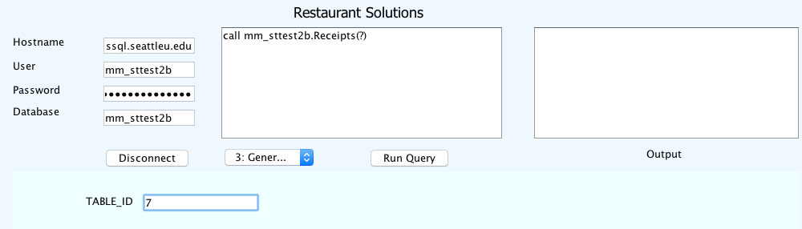

* Query 4: Complete order and clear table
  + Enter in the Table ID number to update the database tables to reflect that the order is completed, and the restaurant table is now open for new customers.

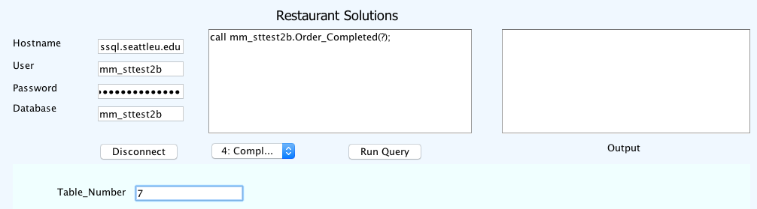

* Query 6: Add new customer
  + Enter the name of the customer, the customer’s email address, and their phone number
  + The phone number and email fields are optional

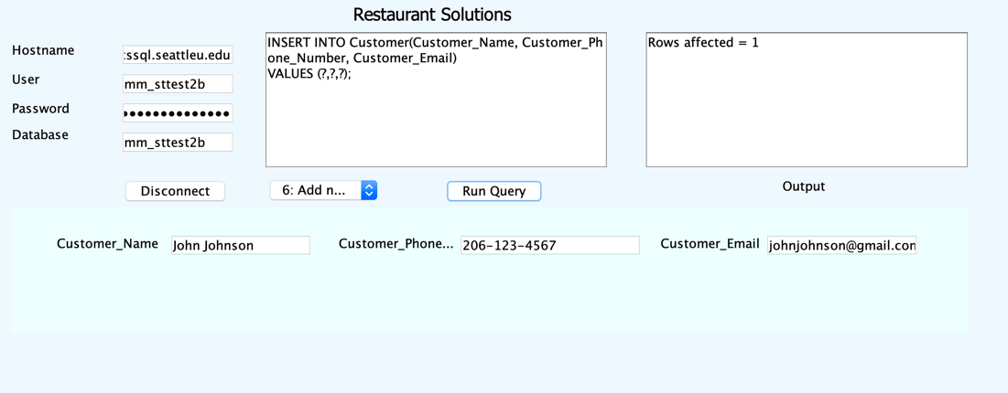

* Query 10: Reservations
  + Enter the desired time and party size to search for available tables.
  + Reservation time: YYYY:MM:DD HH:MM:SS
  + Party Size: any int
  + 